**06 - Azure Storage Table**

**Notes:-**

**1-azure table storage apply NO-SQL data store**

**(Each row applied as entity on the azure storage account)**

**(Each entity has its multiple key, value attributes)**

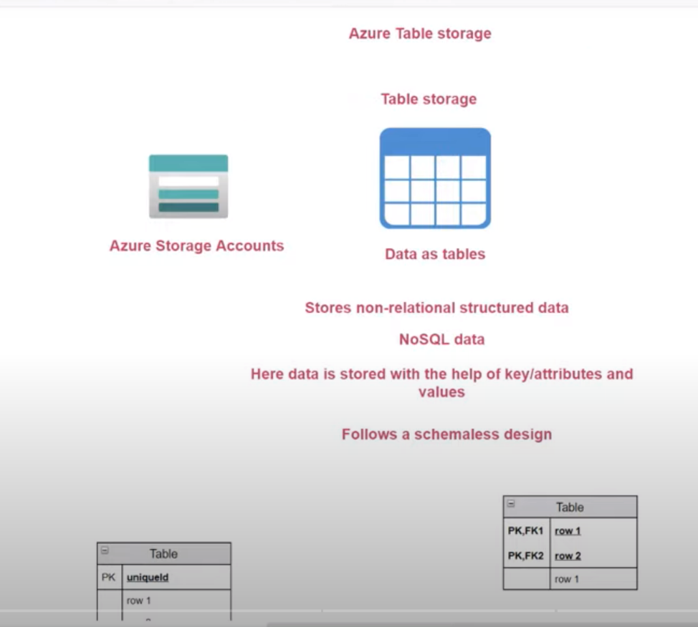

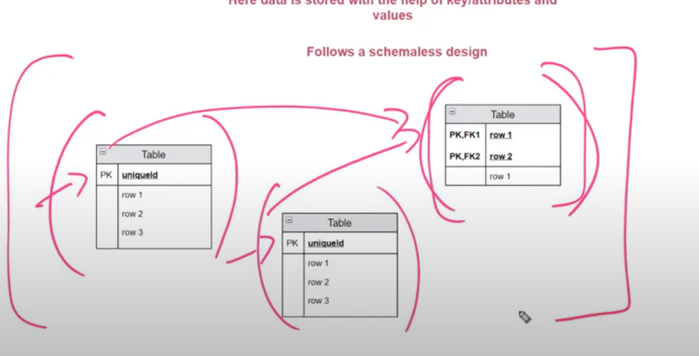

**(with azure table storage it store data in both 2 ways , relational and non-relational , so on relational you have to define the structure and relational on each column on table , while on non-relational table , all you need is to store entity with all props with key value**

**Azure Cosmo Db: is NO-SQL data service that is available on azure and its using Azure storage table**

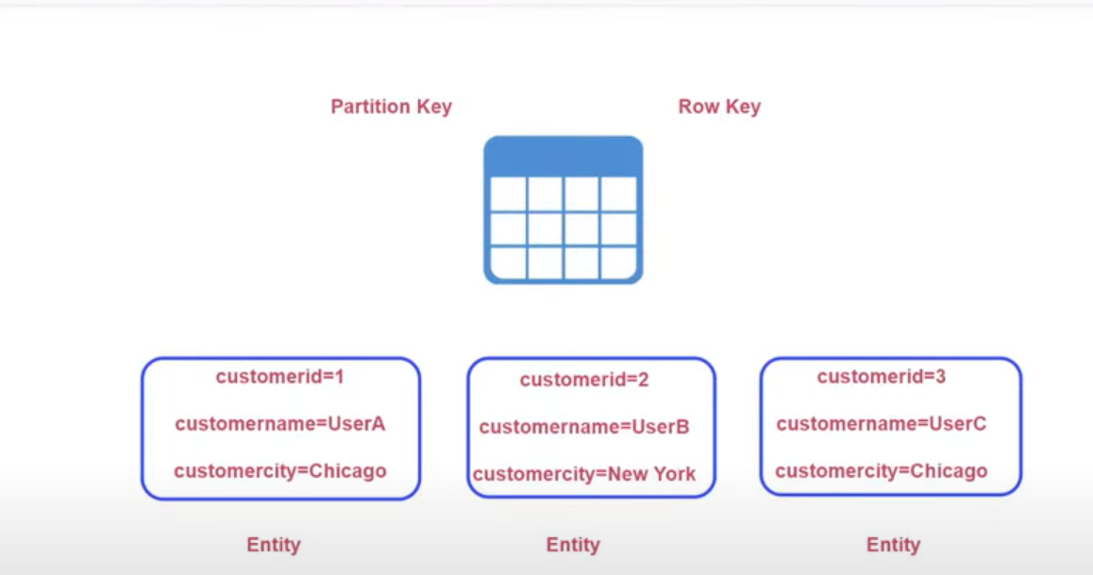

**You can decide on entity which key is partition key and which key is row key like primary key**

**With partition key its useful with partition your data and easy with search on data**

**With make search based on partition key more easy , while on row key to uniquely identity for each entity**

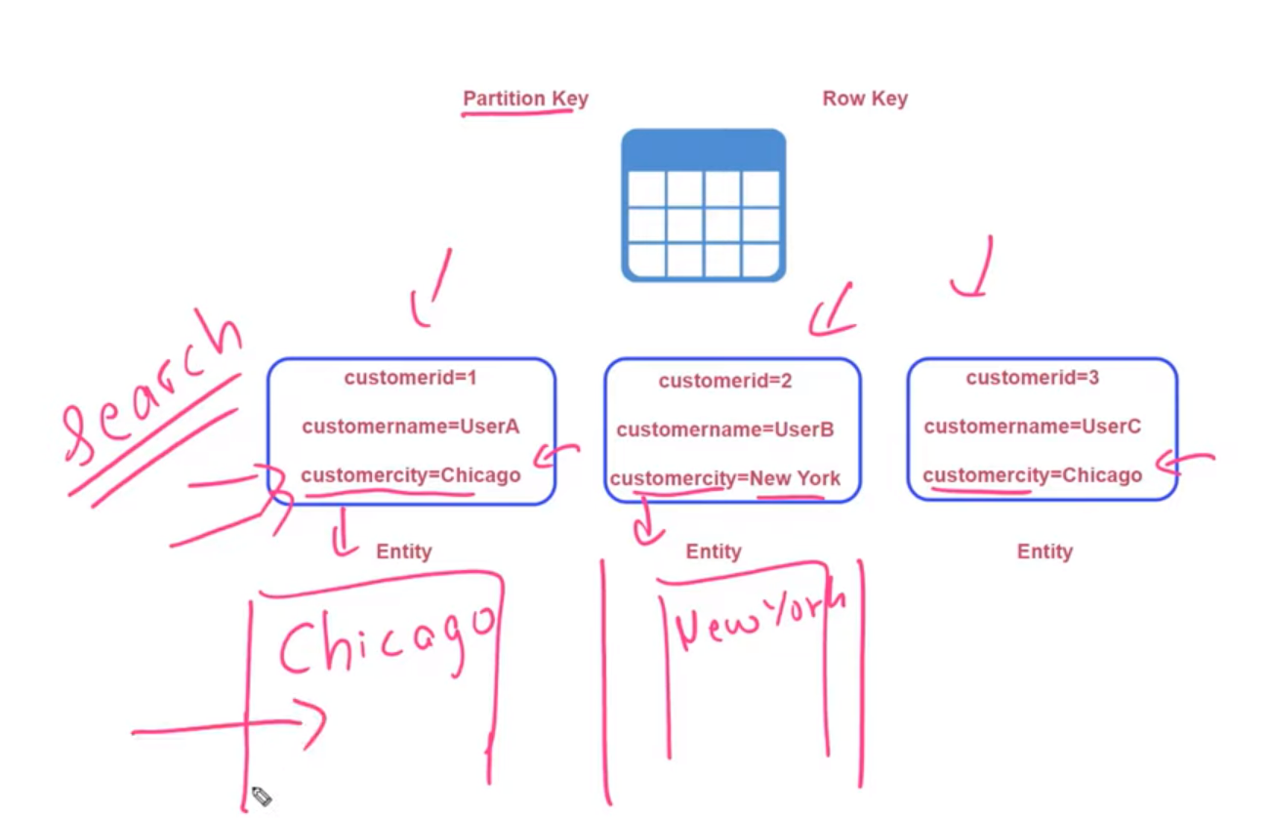

**Steps:-**

**1-on azure storage > Tables > Create new table called Customer**

**2-on Storage Explorer > Add Entity and identity the row key and partition key**

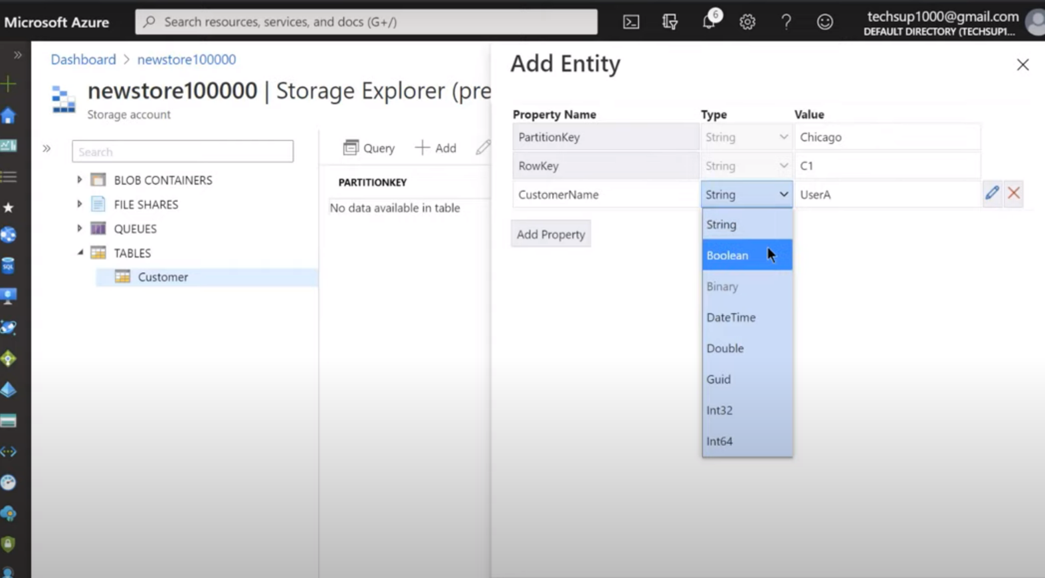

**3-you can make query on the table storage based on the row key or partition key**

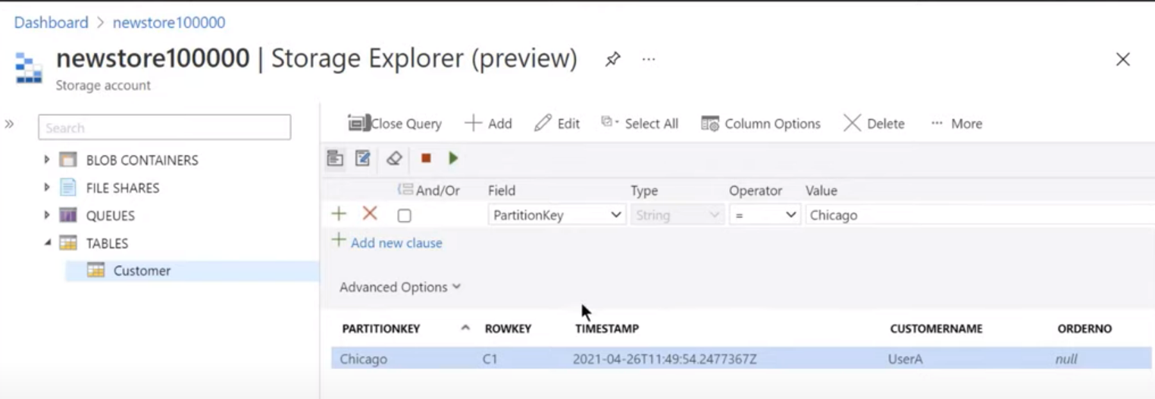

**Steps:-**

**1-on Azure > Nuget > Install Package > Choose Microsoft.Azure.Cosmos.Table**

